User Manual

**for**

**ASTERIX DARR 2.8**

**(Display Analyzer Recorder & Replay)**

[akapetanovic@gmail.com](mailto:akapetanovic@gmail.com)

January 30, 2013

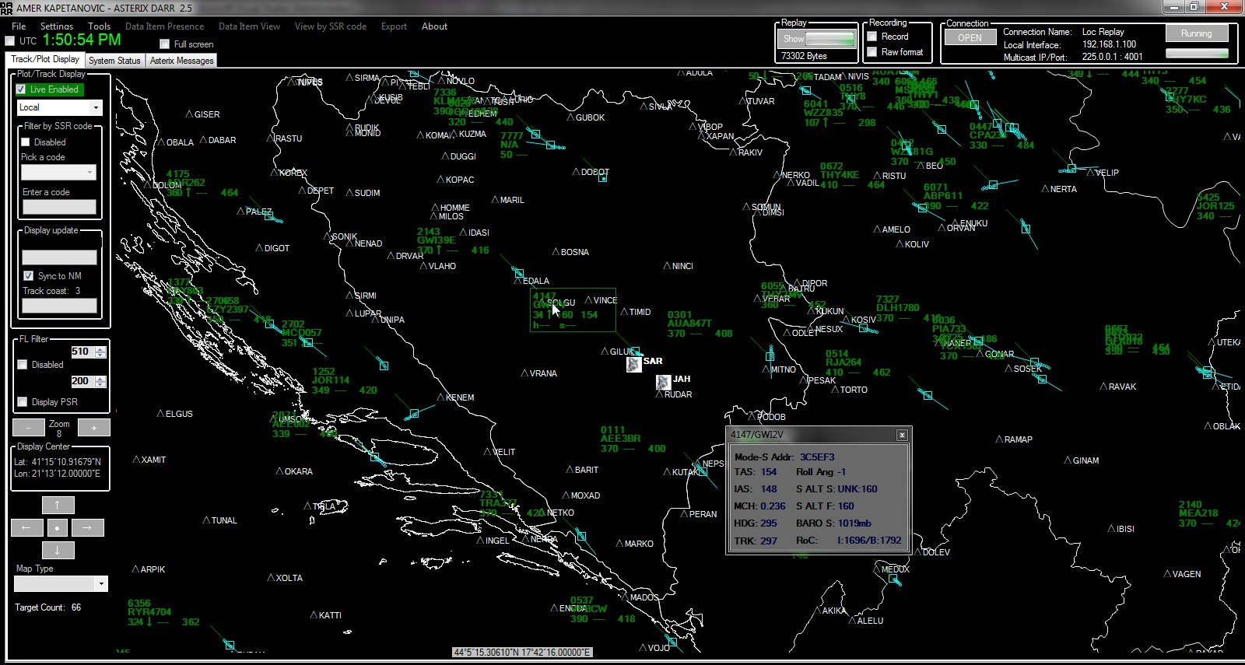

Table of Contents

[Foreword 4](#_Toc343846207)

[Related Documents 5](#_Toc343846208)

[Initial Setup 5](#_Toc343846209)

[Main Windows and Functionality 8](#_Toc343846210)

[Setting up a connection 8](#_Toc343846211)

[8](#_Toc343846212)

[Figure 1: Connection Screen 8](#_Toc343846213)

[Start processing data 9](#_Toc343846214)

[Figure 2: Main Display Window, with full screen selected 9](#_Toc343846215)

[Figure 3: Main Display Window (DISPLAY FROZEN) 10](#_Toc343846216)

[Figure 4: Main Capture Window 11](#_Toc343846217)

[Data Item Presence 12](#_Toc343846218)

[Figure 5: Data Item presences 12](#_Toc343846219)

[Data Item View 13](#_Toc343846220)

[Figure 6: Data Item View 13](#_Toc343846221)

[View by Mode-A Code 14](#_Toc343846222)

[Figure 7: View data by SSR code 14](#_Toc343846223)

[Export (Earth Plot or GePath) 15](#_Toc343846224)

[Figure 8: Export to Earth Plot format by Mode-A code 15](#_Toc343846225)

[Figure 9: 3D example in Google Earth of two (black and pink) landings at Sarajevo airpot. 15](#_Toc343846226)

[Live Display in Google Earth 16](#_Toc343846227)

[Figure 10: Live traffic display in Google Earth 16](#_Toc343846228)

[Figure 11: Settings of Google Earth 17](#_Toc343846229)

[Local Plot/Track Display 17](#_Toc343846230)

[Figure 12: Map with user defined and Google terrain overlay 18](#_Toc343846231)

[Figure 13: Passive display no filter 19](#_Toc343846232)

[Figure 14: Passive filter – by Mode-A code 19](#_Toc343846233)

[Track Label 20](#_Toc343846234)

[Figure 15: Label Example (selected) 20](#_Toc343846235)

[Range and Bearing Tool 21](#_Toc343846236)

[Figure 15.1: Range and Bearing Tool 21](#_Toc343846237)

[SEP Tool 22](#_Toc343846238)

[Figure 15.2: SEP Tool 22](#_Toc343846239)

[Extended Label 23](#_Toc343846240)

[Figure 15.3: Extended label 23](#_Toc343846241)

[(Shows additional data for the selected label) 23](#_Toc343846242)

[Display Attributes 24](#_Toc343846243)

[Figure 16: Menu to Access Display configuration windows 24](#_Toc343846244)

[Figure 17: Display Attributes 25](#_Toc343846245)

[Display Items 26](#_Toc343846246)

[Figure 18: Display Items 26](#_Toc343846247)

[Label Attributes 26](#_Toc343846248)

[Figure 19: Label Attributes Picker 27](#_Toc343846249)

[Choosing Category to Process 27](#_Toc343846250)

[Figure 20: Category decoder selector 27](#_Toc343846251)

[ASTERIX Recording & Forwarding 28](#_Toc343846252)

[Figure 21: Data Recording and Forwarding 28](#_Toc343846253)

[ASTERIX Replay 29](#_Toc343846254)

[Figure 22: ASTERIX Replay 29](#_Toc343846255)

[“Replay” to “Raw” 29](#_Toc343846256)

[Figure 23: Replay to Raw format 29](#_Toc343846257)

[System Configuration and Status 30](#_Toc343846258)

[Figure 24: Three screen shoots of System Status Display (GO, History and Data Loss) 30](#_Toc343846259)

[Miscellaneous Settings 31](#_Toc343846260)

[Figure 25: Miscellaneous Settings 31](#_Toc343846261)

[Implemented Decoders (so far) 31](#_Toc343846262)

# Foreword

ASTERIX DARR (Display Analyzer Recorder & Replay) is a C# /.NET application developed using Microsoft Visual Studio 2010. Initially it started as a small test application intended to read and decode ASTERIX messages. Over the time I have added data display functionality that eventually grew to a full plot/tracker display providing data display filters (by Flight Level Band or Mode-A code), different map (state, sector, airfields, air routes etc..) overlays, adjustable speed vector, history point positions, indication of the “track in coast” state, moving track labels, interactive track label consisting of an assignable CFL, HDG and SPD as well as GND-SPD readout and Range/Bearing Tool. In addition to the above it also provides the following:

1. Extended Label Window (displaying Aircraft Derived Data (CAT048I250 and Cat064I380)
2. ASTERIX stream Recording (up to 6 different data streams).
   1. Recording can be in “raw” or proprietary “replay” format.
3. Replay of ASTERIX “replay” Recordings in the original or up to 10 X faster speed.
4. Opening of ASTERIX “raw” recordings in raw format to analyze and visualize data in Local or Google Earth Display.
5. Export of imported/captured data in KML/KMZ format in order to analyze/visualize it in Google Earth.
6. Export of live/replayed data in real time to Google Earth in order to use it as a data display.
   1. Implemented via Google Earth Network Connection feature.
7. Forwarding of ASTERIX data streams (currently limited up to 5) between networks or to a different multicast address/port.
8. Monitor system status and configuration via CAT034/050

Note that the application uses Visual Basic Power Pack that needs to be installed on the application host machine. On my development machine I have it installed at *C:\Program Files\Reference Assemblies\Microsoft\VBPowerPacks\v10.0\Microsoft.VisualBasic.PowerPacks.Vs.dll* and referenced form VS2010. It can be downloaded at: <http://msdn.microsoft.com/en-us/vstudio/bb735936.aspx>

Lastly, make sure that host machine’s localization is set to English U.S. as application uses .NET libraries (i.e. double.Parse) that depend on localization setting. If not set as expected the software is not able to correctly parse configuration files located in the ***C:\ASTERIX\ADAPTATION*** directory.

The application has been tested using the following data samples:

1. Jahorina MSSR Mode-S: CAT001, 002, CAT034, CAT48
2. Sarajevo APP: CAT001, 002, CAT034, CAT48
3. BHANSA ARTAS: CAT62, MUAC ARTAS CAT062
4. All publicly available data samples at: http://www.recherche.enac.fr/asterix/doku.php?id=userfr

***I would appreciate that anyone with an access to additional data sample sends it to me so that additional testing and validation can be performed.*** The data samples can be in the following formats:

* Raw, using any available recording tool, including this application as well.
* Replay. (using this application)
* Final Format. (gengate tool)

# Related Documents

* EUROCONTROL STANDARD DOCUMENT FOR RADAR DATA EXCHANGE Part9: Category 062 SDPS Track Messages SUR.ET1.ST05.2000-STD-09-01
* EUROCONTROL STANDARD DOCUMENT FOR RADAR DATA EXCHANGE Part4: Category 048 Transmission of Monoradar Data Target Reports SUR.ET1.ST05.2000-STD-04-01
* CAT02 EUROCONTROL STANDARD DOCUMENT FOR Radar Data Exchange Part 2b Transmission of Monoradar Service Messages SUR.ET1.ST05.2000-STD-02b-01
* CAT 34 EUROCONTROL STANDARD DOCUMENT FOR Radar Data Exchange Part 2b Transmission of Monoradar Service Messages SUR.ET1.ST05.2000-STD-02b-01
* EUROCONTROL STANDARD DOCUMENT FOR RADAR DATA EXCHANGE Part 2a Transmission of Monoradar Data Target Reports CAT01 SUR.ET1.ST05.2000-STD-02a-01
* Elementary Surveillance (ELS) and Enhanced Surveillance (EHS) Validation via Mode S Secondary Radar Surveillance (MASSACHUSETTS INSTITUTE OF TECHNOLOGY Project Report ATC-337)
* Technical Provisions for Mode S Services and Extended Squitter (ICAO DOC 9871 AN/464)

# Initial Setup

The application is configured via following configuration files that are located in ***C:\ASTERIX\*** directory that contains the following directories and configuration files:

***C:\ASTERIX\ADAPTATION***

* ***DisplayAttributes.txt*** (*Not to be manually modified*)
  + Defines display attributes for the display maps. The application provides GUI for changing display attributes (see: ***Display Attributes*** for details).
* ***Main\_Settings.txt*** (*Not to be manually modified*)
  + - The system ***display origin point*** (LAT/LNG of the default center of the display map. The parameter is defaulted to the center of Bosnia and Herzegovina but can be modified using application GUI to any other location. (See: ***Display Attributes*** for details).
    - Display ***background color***. The parameter is defaulted to black but can be modified using application GUI to a desired color. (See: ***Display Attributes*** for details).
* ***Radars.txt*** (*To be manually modified*)
  + Defines radar positions (LAT/LNG). Please see the file for the proper syntax. If no file is provided then by default Sarajevo APP and Jahorina radars are defined. ***All radar data streams to be processed have to be defined in this file.***
* ***Sectors.txt*** (*To be manually modified*)
  + Draws sector borders. See the file for the proper syntax and modify it as needed.
* ***States.txt*** (*To be manually modified*)

* + Draws state borders. See the file for the proper syntax and modify as needed. Provided data was obtained from <http://www.gadm.org/country>. Some manual modification is needed though.
* ***Waypoints.txt*** (*To be manually modified*)
  + Draws fixpoints. See the file for proper syntax and modify as needed.
    - ***NOTE:*** *The last parameter is needed but is not used at this time. It is intended to flag the point as a COP (Coordination point) and is included for the future application growth.*
* ***LabelAttributes.txt*** (*Not to be manually modified*)
  + Defines Track/Plot Label display attributes. Use provided GUI for modification. Please see ***Label Attributes***
* ***Runways.txt*** *(To be manually modified*)
  + Draws runway and taxiway borders. See the file for the proper syntax and modify it as needed.

***C:\ASTERIX\IMAGES***

* ***radar.jpg*** (jpg image to be used for radar presentation on the local display)
* ***waypoint.jpg*** (jpg image to be used for waypoint presentation on the local display)

***C:\ASTERIX\GE***

* ***ac\_image.png*** *(an image that Google Earth uses for Track/Plot display when displaying in real time.*
* ***ASTX\_TO\_KML*** *(auto generated file that is used by Google Earth to display data in real time).*

***C:\ASTERIX\***

* ***Asterix\_Export.txt*** *(auto generated by the Google Export functionality)*

# Main Windows and Functionality

Once started the ***Main Screen*** opens up and initially there are no plots/tracks displayed. ASTERIX data has to be either imported from a “raw” ASTERIX recording or acquired from LAN (live or replayed).

To open up a recording go to ***File -> Open Asterix Recording*** and browse to the file.

To acquire live/replayed data the PC where ASTERIX DARR is running has to be on the same network as the hardware which is providing the data so that application gets the ASTERIX data via known multicast IP and PORT number.

**NOTE:** For demonstration/testing purposes two sets of data samples are provided located in the VS2010 solution in DATA SAMPLE directory. Those can be used to either open up sample data in “raw” or “replay” using the replay functionality.

# Setting up a connection

### *C:\Users\CAAS\Desktop\Release\Connection Settings.jpg*

### Figure 1: Connection Screen

To start, from the Main Screen (Figure 2) open up ***Settings -> Connection Settings or directly from the Main Screen under Connection*** (Figure 1), and enter required data. It is possible to enter several connections and save them in a file. Later on, one can open up the file and activate one of the saved connections. Upon opening the form the software will check for the available network interfaces and pre-fill the “Local Interface Addr” combo box with IP addresses. It is also possible to enter one manually.

***Tip:*** *In the case that data is replayed using build in Replay functionality then the fastest way is to also set up the connection from the Replay GUI. (See Replay ASTERIX for details).*

# Start processing data

Once a connection is activated to start processing the data, it is necessary to enable it from the Main Screen using the upper right button (***Stopped/Running***). Once the processing is activated the screen will start to populate as shown in Figure 2.

### C:\Users\CAAS\Desktop\ScreenHunter_55 Dec. 23 13.51.jpg

### Figure 2: Main Display Window, with full screen selected

* The map center can be adjusted either by using GUI buttons or using UP/DOWN/LEFT/RIGHT keyboard keys.
* Zoom IN and Zoom OUT can be adjusted either by GUI buttons or +/- keyboard keys.
* *Recommended way to move the map and control ZOOM is to use the middle mouse button. By moving a mouse while holding middle button the map can be moved. By clicking anywhere on the map and scrolling the middle button (forward and backward) the zoom is increased or decreased.*

**FROZEN DISPLAY:**

If no valid ASTERIX data is received for 2 seconds while a connection is activated “Running” and Plot/Track display is enabled then “FROZEN DISPLAY” message is displayed on the screen. This is to warn the user that display is not being updated.

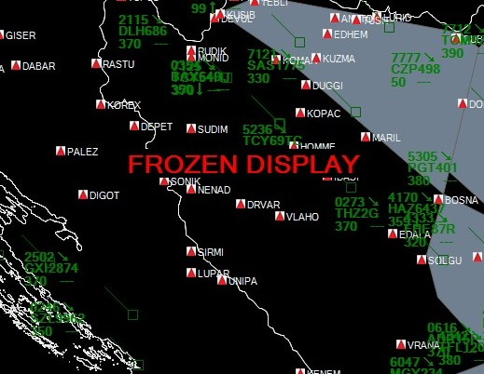

### Figure 3: Main Display Window (DISPLAY FROZEN)

### C:\Users\CAAS\Desktop\Release\Capture window.jpg

### Figure 4: Main Capture Window

Once some data is buffered, it can be analyzed either by looking at the Main Screen under the Asterix Messages tab or by one of the below described options. Note that live update of the Asterix Messages tab can be enabled or disabled. In the case the application is used only for displaying, it is recommended to disable it as it improves the performances and uses less PC resources. This window is intended for quick analysis tasks and should not be used for long sessions.

# Data Item Presence

This view provides info on what data items were detected for a given message category for the latest acquired data sample.

### *C:\Users\CAAS\Desktop\Release\Data Item Presence.jpg*

### Figure 5: Data Item presences

So far the data item presence for the following ASTERIX categories is implemented:

* CAT 001
* CAT 002
* CAT 008
* CAT 034
* CAT 048
* CAT 062
* CAT 063
* CAT 065

# Data Item View

This view lists all the given data items in the order they were received for the given data sample. It does not filter the data so for CAT001 and CAT048 it is much better to use “View by SSR Code”.

### *C:\Users\CAAS\Desktop\Release\Deatalied Item view.jpg*

### Figure 6: Data Item View

# View by Mode-A Code

### C:\Users\CAAS\Desktop\Release\Data By Mode A code.jpg

### Figure 7: View data by SSR code

This view provides the following data (CAT001 or CAT048), filtered by Mode-A code in the order received:

* Range from the surveillance source
* Azimuth from the surveillance source
* Lat/Long from the surveillance source
* Mode C code Validated (TRUE/FALSE)
* Mode C code Garbled (TRUE/FALSE)
* Mode C value

# Export (Earth Plot or GePath)

### *C:\Users\CAAS\Desktop\Release\Google Erth Exporter.jpg*

### Figure 8: Export to Earth Plot format by Mode-A code

### *C:\Users\CAAS\Desktop\Release\DHL-ADRIA Landing at Sarajevo.jpg*

### Figure 9: 3D example in Google Earth of two (black and pink) landings at Sarajevo airpot.

This option decodes and exports a data sample, filtered by a Mode-A code, to either Earth Plot or GePath supported file formats that then can be used to export data into a KML file, used by Google Earth. The final result is the possibility to display/visualize a track from the data sample as a 3D track in Google Earth, as shown in Figure 9.

Auto generated file is upon Exporting placed in ***C:\ASTERIX\Asterix\_Export.txt.***

# Live Display in Google Earth

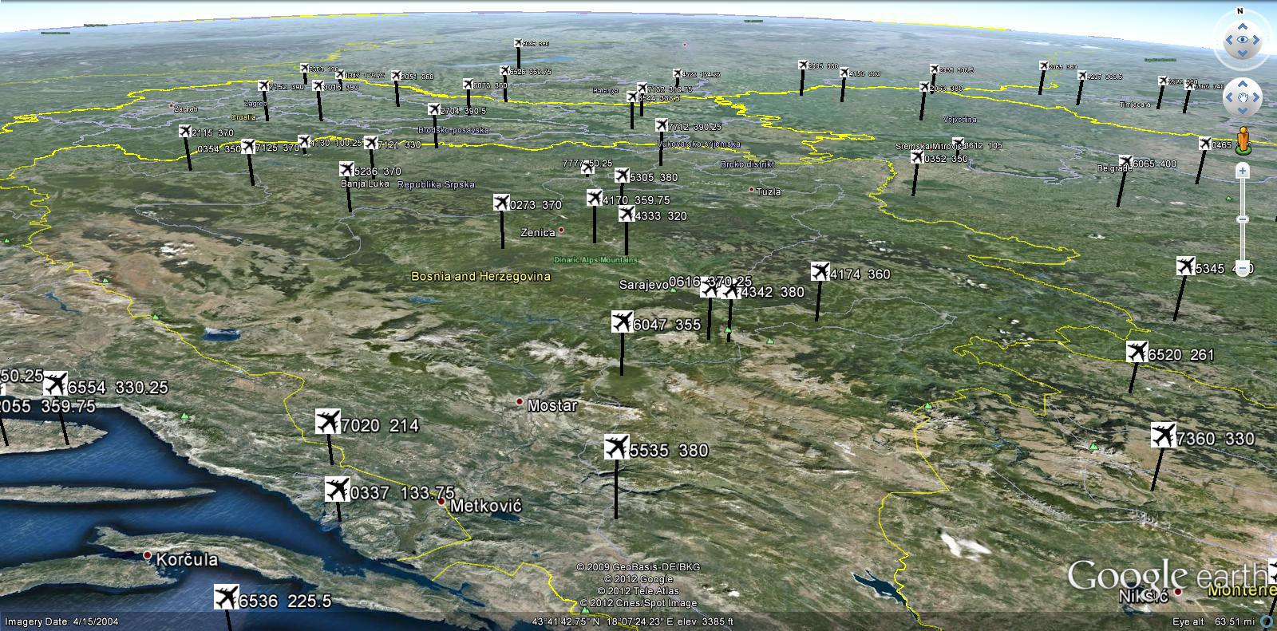

### Figure 10: Live traffic display in Google Earth

It is possible to set up the application to auto-generate xxx.kmz file (each update cycle) that is then automatically processed by Google Earth (via Network Connection). The final result is that Google Earth can be used as a 3D data display. If desired, a web server could be configured to provide the xxx.kmz file so that data could be accessed via a web browser (Google maps) or any other web page with embedded Google maps.

The live display in Google Earth is enabled by selecting the display mode from the ***Plot Display Tab*** to ***“Google Earth”*** or ***“Local and Google E”***

Using Google Earth Provider (***Settings -> Google Earth***) it is possible to specify what data items are displayed in the Google Earth. In addition to that it is possible to specify the **“Dest Folder”** as a location where application places ***ASTX\_TO\_KML.kmz*** file. Google Earth is to be configured via its Network Connection to monitor the folder for the updated data (xx.KMZ file).

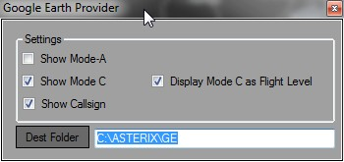

### Figure 11: Settings of Google Earth

# Local Plot/Track Display

Local Plot/Track display functionality provides capability to display received plots/tracks either in real time or buffered/imported data. It provides filter capability (by Mode-A code and/or Flight Level band) as well as to dynamically adjust update rate in order to match the antenna full cycle time period of a specific radar in the case no North Mark message is available. If North Mark message is available it is recommended to use ***“Sync to NM”*** option. **Note: In the case no North Mark message is available *“Sync to NM”* has to be unchecked in order to see Plots/Tracks. As the application is looking for one to update the display.**

The data display can be real time or passive. The passive display is an option to visualise all the buffered data (each recived target) including options to use one of the available filters (By Mode-A code or Flight Level band), as depicted in Figure 12 and 13. It is also possible to filter out PSR targets. The filters are applicable to passive and real time displays.

***NOTE:*** *Application uses WEB map provider Google, so the first time it is started it is necessary to have an internet connection so application is able to cache the maps. While on the internet “zoom in” so maps with the appropriate resolution are downloaded. Later on no internet connection is required as maps are locally cached and application can be used offline.*

### *C:\Users\CAAS\Desktop\ScreenHunter_32 Nov. 18 16.13.jpg*

### Figure 12: Map with user defined and Google terrain overlay

The following four options are available via ***Map Type*** list box:

* Google Plain
* Google Satellite
* Google Terrain
* Google Hybrid
* Custom Build

Custom Build elements are always shown. However, the individual elements of the Custom Built map can be enabled or disabled as described in ***Display Items*** section of the User Manual.

### C:\Users\CAAS\Desktop\ScreenHunter_34 Nov. 18 16.16.jpg

### Figure 13: Passive display no filter

### C:\Users\CAAS\Desktop\ScreenHunter_39 Nov. 18 16.59.jpg

### Figure 14: Passive filter – by Mode-A code

(DHL landing at Sarajevo airport on 29th of September 2012)

Display zoom-in and zoom-out can be done via mouse middle/scroll button. Map can be moved in any direction using the mouse while holding the right mouse button pressed. Both functions are also provided via application GUI.

# Track Label

### C:\Users\CAAS\Desktop\ScreenHunter_52 Nov. 26 19.54.jpg

### Figure 15: Label Example (selected)

Track label can be in **selected** (mouse hovers above it) and **non-selected state**. Selected label shows more information than non-selected. The following are available data fields.

* Mode-3A (**selected and non-selected**)
* Callsign (when available) (**selected and non-selected**)
* Coast state (indicated by ↘ pointing arrow next to Mode A 4147)
  + Coast indicates that track has not been updated by the sensor data for the present update cycle. (**selected and non-selected**)
* AC vertical profile (Mode-C and Climbing/Descending indicator up or down arrow) (**selected and non-selected**)
* Assigned CFL (user enterable) (**selected and non-selected**)
* Assigned HDG (user enterable)(**selected**)
* Assigned SPD (user enterable)( (**selected**)
* Ground Speed - ***derived from CAT064I380, next version will also implement GSPD form CAT048I250***)
* Speed Vector - ***shows TRK/HDG and distance traveled in range of 1 to 9 minutes (configurable***)
* History points - ***shows 1 to 9 history position points (configurable***)

To move a label just place the mouse over the label and move it in the desired direction while holding left mouse button. Please note that the label box is shown only when a mouse is over the label.

# Range and Bearing Tool

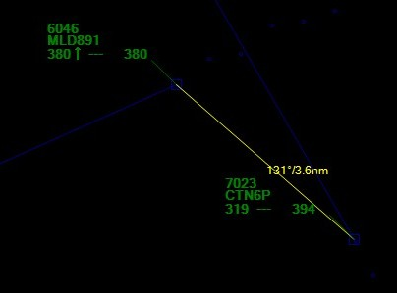

### Figure 15.1: Range and Bearing Tool

Range and Bearing tool is a GUI tool that provides capability to measure range and bearing between any two points on the screen. It is done by selecting any point via mouse right button click and while holding the button dragging the yellow range/bearing line and readout to any other point on the screen.

In the case two tracks symbols are selected the yellow range/bearing line remains on the screen and gets updated every screen update cycle. It is possible to cancel the range/bearing line and readout by right mouse button click on any of the two connected tracks.

# SEP Tool

(Separation Tool)

The SEP tool is an extension of Range and Bearing tool in the way that once two tracks are coupled via R&B tool the system will automatically employ the SEP Tool logic (airspeed vector extrapolation) and check whether in the future vertical separation will get smaller than the present one. If true, then the SEP Tool will get activated and system will display a graphical presentation showing the minimum predicted distance and time until the minimum distance is reached. The display is updated each update cycle and the SEP Tool can be cancelled by left button mouse click on any of the two coupled tracks symbols. It is possible to adjust the maximum SEP Tool extrapolation time in Miscellaneous Settings.

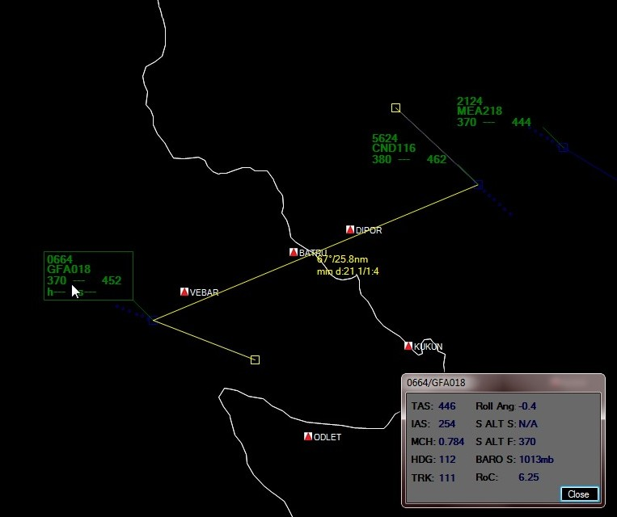

### Figure 15.2: SEP Tool

# Extended Label

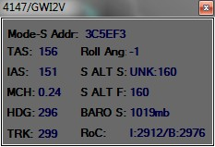

### Figure 15.3: Extended label

### (Shows additional data for the selected label)

Extended Label displays DAP (Derived Aircraft Performance) data for the currently selected Track label. The data is derived from CAT064I380 and CAT048I250 messages.

* *When (Roc) Rate of Climb is derived from CAT048I250 then both Inertial and Barometric are displayed if available.*
* *S ALT S: The short-term vertical intent as described by either the FMS selected altitude, the Altitude Control Panel Selected Altitude (FCU/MCP), or the current aircraft altitude according to the aircraft's mode of flight.*
  + *If the short term target altitude source data is available it is indicated by the following three letter abbreviation in front of the value readout:*
    - *“A/C” Current Aircraft Altitude*
    - *“MCP” MCP/FCU selected altitude*
    - *“FMS” FMS derived altitude*
    - *“UKN” Unknown or Not Provided source*
* *S ALT F: The final vertical intent value that corresponds with the ATC cleared altitude, as derived from the Altitude Control Panel (FCU/MCP).*
  + *If the final vertical intent flight mode data is provided it is indicated by the following three letter mode indicator in front of the value readout:*
    - *“AH” Altitude Hold*
    - *“AM” Approach Mode*
    - *“MV” Managed VNAV*
* *Figure 5.1 depicts data derived from CAT048/I250.*

# Display Attributes

Display attributes window is accessed either via the Main Window from ***Settings -> Display Attributes*** or by ***right button mouse click from the Display Window*** where an option to open up the Display Attributes Window is shown. This window is used to adjust display attributes as shown in Figure 16 as well as to adjust the following:

1. Speed Vector: (1 to 9) represents the distance traveled in minutes as the current speed.
2. History points: (1 to 9) number of displayed history position points.

### *C:\Users\CAAS\Desktop\ScreenHunter_45 Nov. 26 19.36.jpg*

### Figure 16: Menu to Access Display configuration windows

To check/modify specific display attribute first select ***Display Items***, and then modify an applicable attribute.

***NOTE: Although not all attributes are applicable to each Item all attributes are available for the implementation simplicity. Example: Line Attribute is not applicable to radar but is to State Border line.***

### *C:\Users\CAAS\Desktop\Release\Display Attibutes.jpg*

### Figure 17: Display Attributes

Display attributes window is accessed by the right button mouse click from the Display Window that then provides the option to open up the Display Item.

# Display Items

### *C:\Users\CAAS\Desktop\ScreenHunter_36 Nov. 18 16.18.jpg*

### Figure 18: Display Items

Display Items option provides a simple way to dynamically enable/disable specific data item on the display. The selection gets saved between application sessions.

# Label Attributes

Label Attributes Window lets you configure Track/Plot Label attributes. The changes can be checked immediately by pressing the “Update” button. Satisfactory selection of the settings can be saved using the “Save” button, in which case they will persist between sessions.

### *C:\Users\CAAS\Desktop\ScreenHunter_37 Nov. 18 16.19.jpg*

### Figure 19: Label Attributes Picker

# Choosing Category to Process

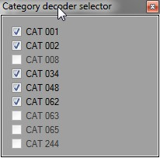

### Figure 20: Category decoder selector

This option allows the user to choose what ASTERIX Category to process and what to ignore.

# ASTERIX Recording & Forwarding

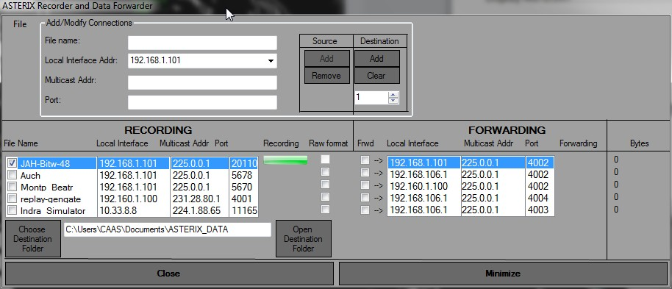

### Figure 21: Data Recording and Forwarding

**Recording**

This function provides the capability to record up to 5 data streams plus of one that can be enabled from the Main Window. The data is stored in the destination directory. The recorded data file has the same file name as was entered during the configuration; it is appended with the recording start date and time. The data is recorded either in the raw format that later can be imported and analyzed/visualized via Local or Google Earth display, or in replay format to be used for Replaying. Note that Raw recording can be opened with the Asterix Inspector (<http://sourceforge.net/projects/asterix/?source=directory>)

**Forwarding**

This function provides the capability to forward up to 5 data streams to a different network interface or IP address/port.

# ASTERIX Replay

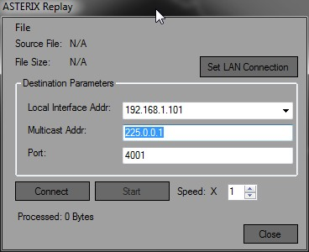

### Figure 22: ASTERIX Replay

The Replay function requires an ASTERIX recording (xxx.rply) file that can be recorded using the built in Recorder. It also requires selecting an appropriate option. To start Replay it is necessary to define network interface, multicast address and port number and lastly to select recoding file. By default the recording is done at the same speed as the original data stream but it is possible to dynamically adjust recoding speed to up to 10 times faster. It is also possible to pause and resume replay.

# “Replay” to “Raw”

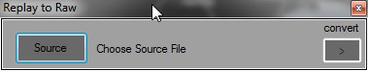

### Figure 23: Replay to Raw format

This tool provides an option to convert ASTERIX “replay” recording to “raw” format. The tool removes the proprietary headers from the data blocks so the file can be either imported “at once” or used with other ASTERIX tools that support “raw” data formats.

# System Configuration and Status

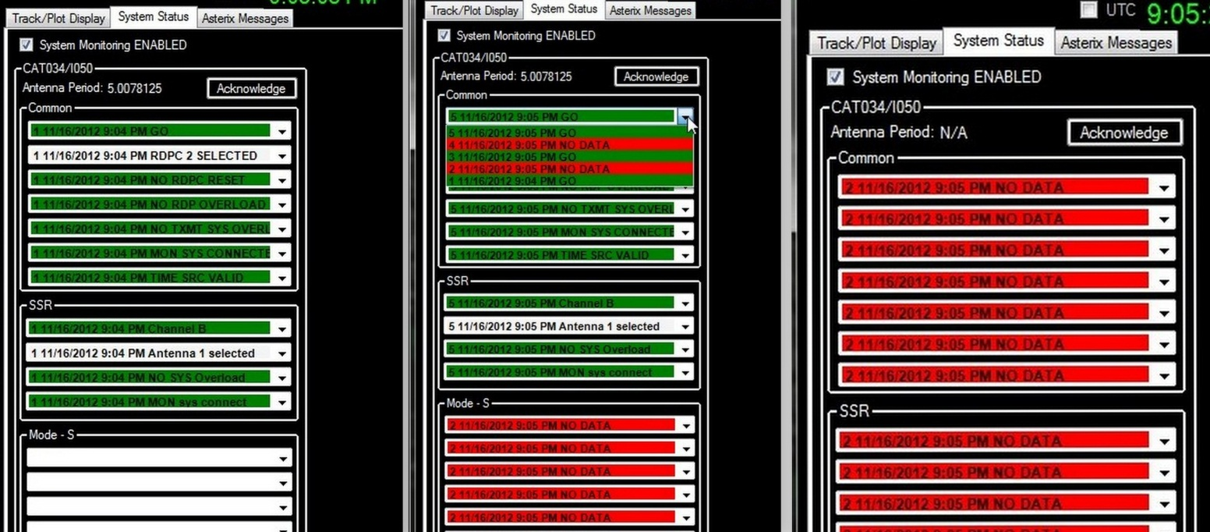

### Figure 24: Three screen shoots of System Status Display (GO, History and Data Loss)

System status is based on CAT034/I050 (System Configuration and Status) data. It constantly monitors the message and anytime a change in a single data item is detected it is logged with a timestamp in the dedicated place. This way it is possible to list all status and configuration events since the last time they are acknowledged by the provided button. System critical events in the case of failure are marked in red while fail condition is present. Once NOGO event transitions GO it marked in Green.

# Miscellaneous Settings

1. “Display Mode C as FL” if checked off then displays Mode C exactly as received from the sensor.
2. “Display position in decimals” if checked then LAT/LNG of the mouse position is displayed in decimal degrees format.
3. SEP Tool (MAX number of minutes to look ahead when using SEP Tool logic)

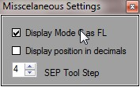

### Figure 25: Miscellaneous Settings

# STCA (Short Term Conflict Alert)

Tralaaa

# Implemented Decoders (so far)

CAT01

020 Target Report Descriptor

040 Measured Position in Polar Coordinates

070 Mode-3/A Code in Octal Representation

090 Mode-C Code in Binary Representation

141 Truncated Time of Day

200 Calculated Track Velocity in Polar Coordinates

CAT02

000 Message Type

020 Sector Number

030 Time of Day

041 Antenna Rotation Period

CAT48

020 Target Report Descriptor

040 Measured Position in Slant Polar Coordinates

070 Mode-3/A Code in Octal Representation

090 Flight Level in Binary Representation

140 Time of Day

220 Aircraft Address

240 Aircraft Identification

200 Calculated Track Velocity in Polar Coordinates

250 Mode-S MB

BDS40 Selected Vertical Intention

1. MCP/FCU Selected Altitude

2. FMS Selected Altitude

3. Barometric Pressure Setting Minus 800mb

4. Status

BDS60 Heading and speed report

1. Magnetic Heading

2. Indicated Airspeed

3. Mach number

4. Barometric Altitude rate

5. Inertial Altitude rate

BDS50 Track and turn report

1. Roll Angle

2. Track Angle

3. Ground Speed

4. Track Angle Rate

5. True Airspeed

CAT34

000 Message Type

030 Time-of-Day

020 Sector Number

041 Antenna Rotation Period

050 System Configuration and Status

CAT62

015 Service Identification

105 Calculated Track Position (WGS-84)

060 Track Mode 3/A Code

040 Track Number

070 Time of Track Information

136 Measured Flight Level

220 Calculated Rate of Climb/Descent

380 Aircraft Derived Data

Subfield # 1: Target Address

Subfield # 2: Target Identification

Subfield # 3: Magnetic Heading

Subfield # 5: True Airspeed (TAS)

Subfield # 6: Selected Altitude

Subfield # 7: Final State Selected Altitude

Subfield # 10: COM, ACAS and Flight Status

Subfield # 15: Roll Angle

Subfield # 17: Track Angle

Subfield # 18: Ground Speed

Subfield # 26: Indicated Airspeed (IAS)

Subfield # 27: Mach number

Subfield # 28: Barometric Pressure Setting (from Mode S BDS 4,0)

***Amer Kapetanovic***

***(akapetanovic@gmail.com)***